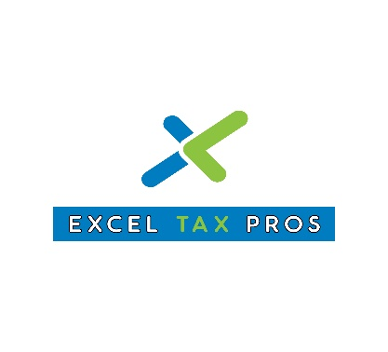
Document Checklist (Businesses)
GENERAL INFORMATION
- Copy of the business tax return 2021.
- Employer identification number (EIN).
- Member or Stockholder information (SS#, name, current address, % ownership, telephone, email address).

REPORTS INFORMATION
- Balance Sheet.
- Profit and loss.
- Sales Tax Summary.
- Payroll summary.
- Schedule of depreciation.

INCOME
- Gross receipts from sales or services.
- Sales records for accrual-based taxpayers (accounts receivable).
- Returns and allowances.
- Business checking/savings account interest (1099-INT or statement).
- Other income, including rental income, federal and state gasoline or fuel tax credit or refund.

COST OF GOOD SOLD
- Beginning inventory total dollar amount.
- Inventory purchases.
- Ending inventory total dollar amount.
- Items removed for personal purposes.
- Materials and supplies.

EXPENSES
- Advertising
- Phones (landline, fax or cell phones related to business)
- Computer & internet expenses
- Transportation and travel expenses
- Local transportation – Did you take any business trips this year? You’ll want to include your mileage along with any car and truck expenses. For public transportation, parking, and tolls, you should include your contemporaneous log (recording of transactions as they happen) or receipts.
- Travel away from home – You should account for mileage or actual expenses if you drove – or airfare for any flights. Be sure to include costs for hotels; meals and tips; and taxi fares and tips. Remember to include any miscellaneous expenses, such as your internet access (hotel, internet café, etc.).

- Commissions and fees
- Contract labor expenses paid to subcontractors and independent contractors
- Depreciation
- Cost and first date of business use of assets
- Records relating to personal use of assets
- Sales price and disposition date of any assets sold
- Documentation of prior-year depreciation

- Amortization of intangible assets (e.g. patents or copyrights held)
- Business insurance
- Casualty loss insurance
- Errors and omissions
- Other

- Interest expense
  - Mortgage interest on building owned by business
  - Business loan interest
  - Investment expense and interest

- Professional fees
  - Lawyers, accountants, and consultants

- Office supplies
  - Pens, paper, staples, and other consumables

- Rent expense
  - Office space rent
  - Business-use vehicle lease expense
  - Other

- Office-in-home
  - Square footage of office space
  - Total square footage of home
  - Hours of use, if operating an in-home daycare
  - Mortgage interest or rent paid
  - Homeowner's or renters' insurance
  - Utilities
  - Cost of home, cost of separate improvements and first date of business use

- Wages paid to employees – Include For 941 – RT-6 – 940 – W-2 and 1099 NEC
- Employee benefit expenses

OTHER EXPENSES
- Repairs, maintenance of office facility, etc.
- Estimated tax payments made (including property taxes and sales taxes if applicable)
- Other business–related expenses
- Health insurance – Whether you’re a sole–proprietor who is covering their family, a partner or you have S corporation shareholders, you’ll want to account for premiums paid on behalf of those individuals. Also, you should gather information on your spouse’s employer provided insurance if applicable.

For more tax information follow us on social media:
Instagram: www.instagram.com/exceltaxpros
Twitter: www.twitter.com/exceltaxpros

